CAMPUS LIBRARY MANAGEMENT SYSTEM USING JAVA

Project Report

Submitted for the Course - Programming in Java

Submitted By:
Name: Avishi Patidar
Registration Number: 25BAI10071
Program: B.Tech / CSE in Artificial Intelligence and Machine Learning
University: VIT Bhopal University

Academic Year: 2026–27
Date of Submission: 17/09/2026

1. Introduction
The Campus Library Management System is a Java-based application developed to manage basic activities of a college library.
The system provides a simple way to manage books and student information. It also allows the user to issue and return books, maintain issue records, search for books, calculate fines for late returns, and view a library summary.
The project is developed using Core Java concepts such as classes and objects, inheritance, polymorphism, collections, exception handling, file handling, and the Java Date and Time API.
The application follows a menu-driven approach, where the user selects an option from the main menu and performs the required library operation.
The main purpose of this project is to demonstrate the practical use of Java programming concepts by developing a simple and functional library management application.

2. Problem Statement
Managing books, students, and book issue and return records manually in a college library can be time-consuming and may lead to errors.
Keeping track of available and issued books can also become difficult when records are maintained manually. Searching for a particular book and maintaining transaction records may require additional time and effort.
The Campus Library Management System is developed to provide a simple computerized solution for these basic library activities. The system helps manage book and student information, issue and return books, maintain issue records, calculate fines for late returns, and provide a summary of library information.
The project aims to make these activities more organized and easier to manage through a simple Java-based menu-driven application.

3. Functional Requirements
The functional requirements describe the main operations that the Campus Library Management System should perform.

3.1 Book Management
- The system shall allow the user to add new books.
- The system shall allow the user to view all available book records.
- The system shall allow the user to search for a book by title.
- The system shall prevent duplicate Book IDs.

3.2 Student Management
- The system shall allow the user to add student details.
- The system shall allow the user to view registered students.
- The system shall validate student information.
- The system shall prevent duplicate Student IDs.

3.3 Book Issue and Return
- The system shall allow a book to be issued to a registered student.
- The system shall check whether the book is available before issuing it.
- The system shall allow an issued book to be returned.
- The system shall update the book status after issue and return.

3.4 Fine Calculation
- The system shall calculate a fine when a book is returned after the allowed borrowing period.
- The fine shall be calculated based on the number of extra days.

3.5 Issue Records
- The system shall maintain records of book issue and return transactions.
- The system shall display issue date, return date, fine, and status.

3.6 Library Summary
- The system shall display the total number of books.
- The system shall display the total number of registered students.
- The system shall display the number of currently issued books.

3.7 File Storage and Error Handling
- The system shall save book, student, and transaction data in text files.
- The system shall display appropriate error messages for invalid input and invalid operations.

4. Non-Functional Requirements
The non-functional requirements describe the quality and performance characteristics of the Campus Library Management System.

4.1 Usability
- The system should have a simple and easy-to-understand menu.
- The user should be able to perform library operations easily.

4.2 Reliability
- The system should handle invalid operations without stopping unexpectedly.
- The system should provide appropriate messages when an operation cannot be completed.

4.3 Performance
- The system should perform basic library operations quickly.
- Searching and displaying records should be efficient for the size of the application.

4.4 Maintainability
- The project should be divided into separate classes according to their responsibilities.
- The code should be easy to understand and modify.

4.5 Error Handling
- The system should validate user input.
- The system should handle invalid numbers, duplicate IDs, missing records, and invalid library operations.

4.6 Resource Efficiency
- The application should use simple data structures and file storage.
- It should run using standard Java resources without requiring additional services.

5. System Architecture

5.1 Architecture Overview
The Campus Library Management System follows a simple layered structure. The user interacts with the system through the menu driven interface. The Main class takes input from the user and calls the required operations from the Library class. The Library class manages books, students, and issue records. Other classes are used for validation, file storage, exception handling, and generating the library summary.

5.2 System Architecture Flow
- Start: The application starts and creates a Library object.
- Display Menu: The system displays options such as adding books, viewing books, searching books, adding students, issuing books, returning books, and viewing reports.
- Accept User Input: The user selects an option and enters the required details.
- Validate Input: The system checks whether the entered information is valid.
- Process Request: The Library class performs the selected operation.
- Update Records: Book, student, or issue records are updated when required.
- Save Data: FileManager stores the updated information in text files.
- Display Result: The system shows a success message or an error message.
- Repeat or Exit: The menu is displayed again until the user selects the Exit option.

5.3 Working of the System
- The user selects an option from the main menu.
- Main.java accepts the required input.
- Input is checked using InputValidator.
- The required operation is performed by Library.
- Book, Student, and IssueRecord objects store the related information.
- LibraryException handles invalid library operations.
- FileManager saves the data in text files.
- ReportManager displays the library summary.

5.4 Architecture Components
1. User Interface Layer
- Provides a menu-driven interface through the command line.
- Accepts input from the user using the Scanner class.
- Displays messages, records, and results.
2. Validation Layer
- Validates book and student details.
- Checks IDs, names, email addresses, and text inputs.
- Handles invalid input through error messages.
3. Library Management Layer
- Manages books, students, and issue records.
- Provides features for adding, viewing, searching, issuing, and returning books.
- Checks book availability and student registration.
4. File Management Layer
- Creates the data folder.
- Saves book, student, and transaction details in text files.
- Uses file handling classes provided by Java.
5. Report Management Layer
- Displays the library summary.
- Shows the total number of books, students, issued books, and available books.

5.5 Technology Used
- Programming Language: Java
- User Interface: Command Line Interface (CLI)
- Data Storage: Text Files
- Collections: ArrayList
- Exception Handling: Custom LibraryException
- Development Environment: Java Development Kit (JDK)

5.6 Architecture Workflow
The user enters a choice through the command-line menu. The Main class receives the input and calls the relevant method of the Library class. The Library class processes the request, validates the operation, and updates the required records. FileManager saves the updated information, while ReportManager displays the library summary when requested.
The modular structure makes the application easier to understand, maintain, and extend.
USER/STUDENT
Command line input
ReportManager
Library Summary
FileManager
Text File Storage
Library.java
Books, students and transactions

InputValidator
Input validation

Main.java
Menu and user interaction

6. Design Diagram
FileManager
Book
IssueRecord
Student
Library
Main (Menu)
USER

7. Design Decisions and Rationale

7.1 Use of Java
Java was selected for this project because the project is developed for the Programming in Java course. Java provides object-oriented programming features, exception handling, collections, and file handling that are useful for developing this application.

7.2 Menu-Driven Interface
A menu-driven command-line interface was used to keep the application simple and easy to operate. The user can select an option from the main menu to perform the required library operation.

7.3 Use of Separate Classes
The project is divided into different classes such as Book, Student, IssueRecord, Library, and FileManager. Each class has a specific responsibility, which makes the program easier to understand and maintain.

7.4 Use of ArrayList
ArrayList is used to store books, students, and issue records. It allows the program to store multiple objects and access them easily during different operations.

7.5 Use of Exception Handling
Exception handling is used to manage invalid input and invalid library operations. A custom LibraryException class is used to display meaningful error messages for library-related errors.

7.6 Use of File Handling
Text files are used to save book, student, and transaction information. This provides simple data storage without requiring a database.

7.7 Use of Java Date and Time API
LocalDate is used to store issue and return dates. The Java Date and Time API is also used to calculate the number of days for fine calculation.

8. Implementation Details
The Campus Library Management System is implemented using Core Java. The project is divided into different classes, where each class performs a specific task. The main implementation details are given below.

8.1 Main Class
The Main class controls the overall execution of the application. It displays the main menu and takes input from the user using the Scanner class.
It uses a switch statement to perform different operations such as adding books, adding students, issuing books, returning books, searching books, and viewing the library summary.

8.2 Book Class
The Book class stores information related to a book, such as:
- Book ID
- Book title
- Author
- Category
- Availability status
The class uses private variables and getter and setter methods to implement encapsulation.

8.3 User and Student Classes
The User class stores common user information such as user ID, name, and email.
The Student class extends the User class and adds the department information. This demonstrates inheritance.
The displayUser() method is overridden in the Student class, demonstrating polymorphism.

8.4 IssueRecord Class
The IssueRecord class stores information about book transactions.
It keeps the book ID, student ID, issue date, return date, fine, and return status.
The LocalDate class is used for dates, while ChronoUnit.DAYS is used to calculate the number of days between issue and return dates.

8.5 Library Class
The Library class contains the main library operations.
It manages three ArrayList collections for:
- Books
- Students
- Issue records
The class provides operations such as adding books and students, searching books, issuing books, returning books, and displaying records.

8.6 InputValidator Class
The InputValidator class is used to check user input before performing operations.
It validates:
- Names
- Email addresses
- IDs
- Text fields
This helps prevent invalid data from being added to the system.

8.7 LibraryException Class
LibraryException is a custom exception created for handling library-related errors.
It is used for situations such as duplicate IDs, missing books or students, and trying to issue or return a book in an invalid situation.

8.8 FileManager Class
The FileManager class handles saving library information into text files.
The system saves:
- Book information in books.txt
- Student information in students.txt
- Transaction information in transactions.txt
File handling is implemented using Java's File and FileWriter classes.

8.9 ReportManager Class
The ReportManager class generates a simple library summary.
It displays:
- Total number of books
- Total number of students
- Number of currently issued books

8.10 Data Storage
The project uses simple text files for storing library data. A separate file is maintained for books, students, and transactions.

9. Screenshots:

9.1 Project Successfully Run:
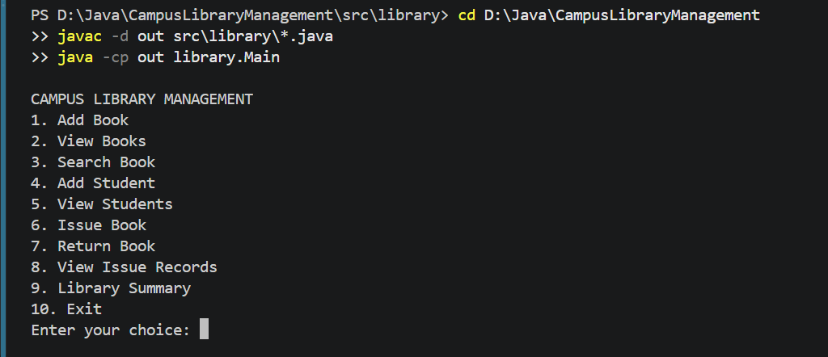

9.2 Add Book:
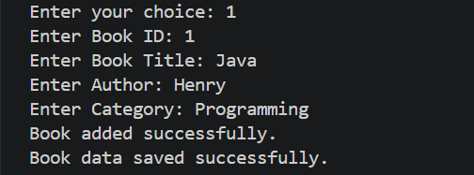

9.3 Add Student:
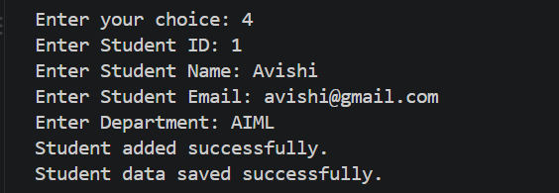

9.4 Issue Book:
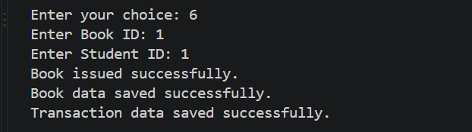

9.5 Return Book:
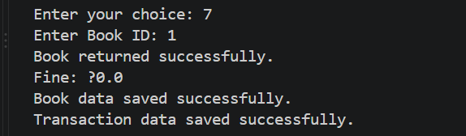

9.6 Library Summary:
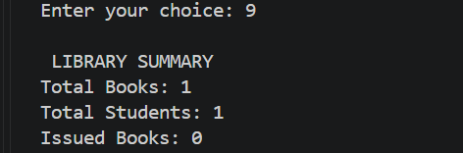

10. Testing Approach
The Campus Library Management System was tested by running the application through the command line and checking its main features. Different inputs were used to check whether the system works correctly and handles invalid inputs properly.

10.1 Testing Methods
- Functional Testing: Checked whether the main features work as expected.
- Input Validation Testing: Tested invalid IDs, names, and email inputs.
- Error Handling Testing: Checked how the system responds to invalid library operations.
- File Handling Testing: Checked whether book, student, and transaction data are saved correctly.

10.2 Test Cases
Test Case | Input/Operation | Expected Result
Add Book | Enter valid book details | Book is added successfully
View Books | Select View Books | Displays the available books
Search Book | Enter a book ID or title | Displays matching book details
Add Student | Enter valid student details | Student is registered successfully
Issue Book | Enter valid book and student IDs | Book is issued successfully
Return Book | Enter an issued book ID | Book is returned and the record is updated
Invalid Input | Enter incorrect details | Error message is displayed
Library Summary | Select Summary | Displays library statistics

10.3 Testing Result
The application was tested using different menu options and input values. The testing process helped identify input errors and check the working of book management, student management, book issuing, book returning, and library summary features.

11. Challenges Faced
While making this project, I faced some difficulties in connecting different Java classes and making them work together. Handling invalid inputs, checking book availability, and managing the issue and return process took some time to understand.
I also faced challenges while implementing file handling because I had to save book, student, and transaction details in separate text files. Understanding exception handling and connecting all the features with the main menu was another learning experience.
Overall, these challenges helped me improve my understanding of Java and gave me practical experience in developing a small working project.

12. Learnings & Key Takeaways
While working on this project, I learned how to use Java to create a simple application instead of writing only individual programs. I got a better understanding of classes, objects, ArrayList, and exception handling.
I also learned how to save data in text files and connect different features through the main menu. At first, managing multiple classes and fixing errors was a little difficult, but working on the project helped me understand these concepts better.
Overall, this project gave me practical experience with Java and helped me become more comfortable with programming.

13. Future Enhancements
In the future, I would like to add a graphical interface to make the project easier to use. I also want to replace text files with a database so that managing records becomes simpler.
I would also like to add features such as student login, book availability notifications, and a better search option. Later, I could turn this project into a web application so students can check books and library information online.
These changes would help me improve the project and make it more useful for students and library staff.

15. References
- Deitel & Deitel – Java: How to Program. Referred to for understanding Java programming concepts and object-oriented programming.
- Oracle Java Documentation – Used to understand Java syntax, classes, and methods.
- VITyarthi Learning Materials – Referred to the course content and project guidelines.
- Class Notes and Practical Learning – Used to understand collections, exception handling, and file handling.
- Personal Coding Practice – Used to develop and test the Campus Library Management System.

